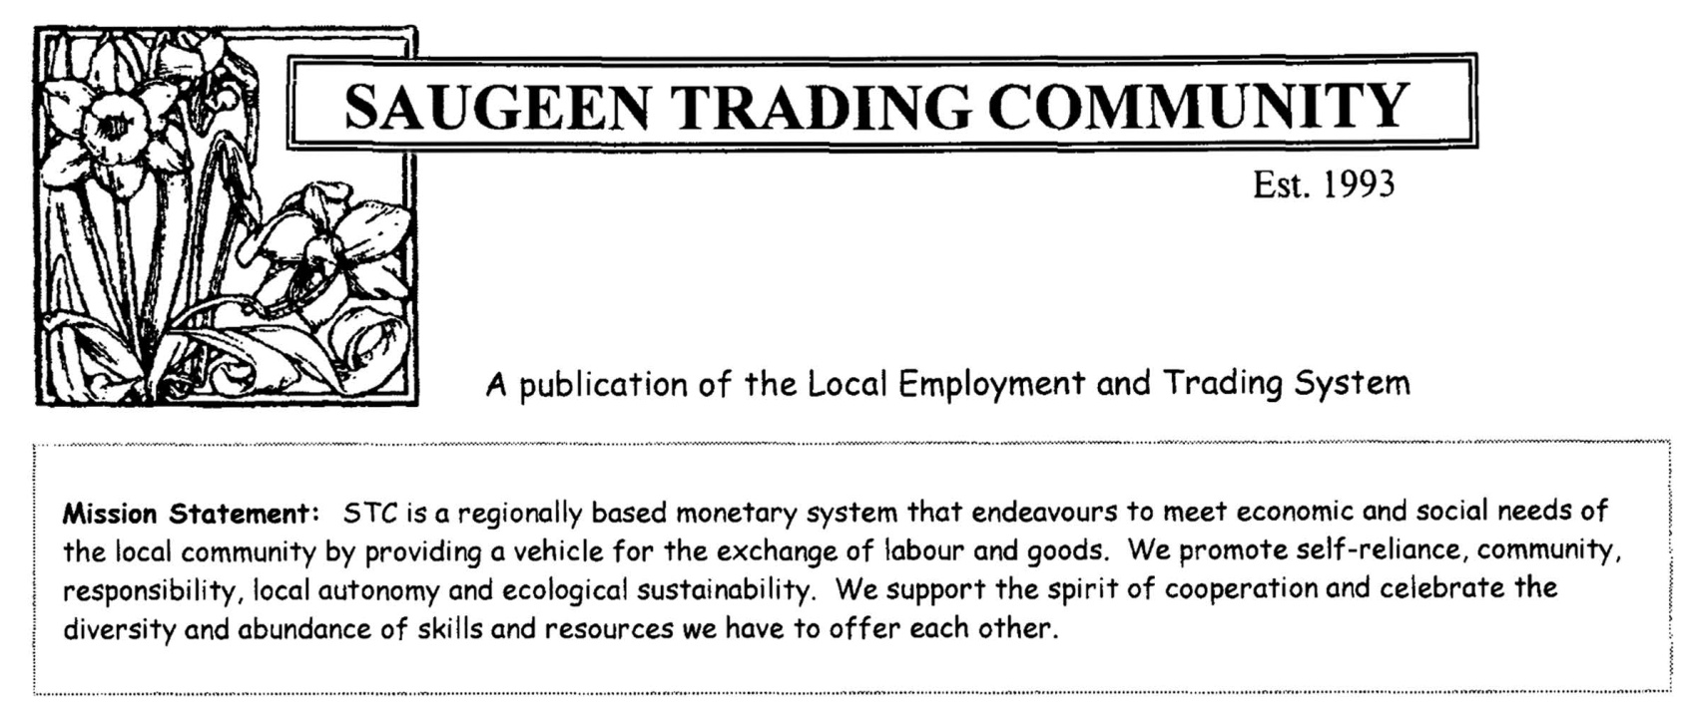

S.T.C. TRADING MANUAL

MONEY & SAUBUCKS

We humans invented money. It was never meant to be more than a record of the value of trade. In the evolution of money from valuables like cattle and tobacco, to metal bars and coins, to paper notes and cheques, and now to numbers electronically stored in computer files and electronically transmitted between them, we continue to evolve our understanding of money and its social role.

The Saugeen Trading Community (STC) reclaims the real essence of money. STC actively supports people trading with each other by providing an information tool – a currency (saubucks) and information about who’s offering what – and then lets people get on with it. It fosters an economy driven by transactions/trades rather than the pursuit of money itself.

Saubucks exist only as information. But they are never made out of thin air. They are created when people do something of real value and trade it with someone else. The creation of saubucks is directly related to its real source: our skills and creativity as people.

Many people’s resourcefulness and creativity are underused in the present economy of redundancies, long term unemployment and isolation. When there is work to be done, and there are people willing to do it, money becomes an obstacle we need to overcome.

As long as money has been something you passed from hand to hand, it has had a life of its own – a commodity like the goods and services we actually trade. Money in the form of coins or paper had to be created, issued and put into circulation by someone, but with the arrival of electronically stored information – money simply as information – it is clear that money is essentially a scoring system that records the value of the transactions between people. Using a trading system, people actually create their own currency as they trade. Our wealth of enterprise and ingenuity gets the expression it needs. The Saugeen Trading Community offers people a deeper way to become involved in their community.
WHAT IS IT?

The Saugeen Trading Community (STC) is a local employment trading system with a currency (saubucks) of its own.

IT CONSISTS OF:

- A list of members
- A Goods & Services Listings
- Regular saubuck (SB) statements
- A website
- A regular newsletter
- A legally binding agreement that is signed by each member

WHAT ARE SAUBUCKS?

A saubuck both resembles and is different from a Canadian “federal” dollar. Each saubuck is considered to have the same value as a federal dollar, but no bills are issued. Instead, an STC member transfers saubucks from her/his account to another member’s account as payment for goods or services received from that member. Saubucks constantly move from one account to another, never leaving the system, always providing a source of income to the members involved in trading.

Each member starts with a zero balance and saubucks are created as needed by the people who use them. You can actually spend saubucks before you have earned any. There is however a debt limit of 250 saubucks for the first year OR until a trading record has been established.

Unlike a bank there is no interest charged or earned on STC account balances. In effect, every member in the community trading system is self-employed.

HOW DOES IT ACTUALLY WORK?

Here’s an example. Let’s say Joanne has a truck for hire and Kevin is a carpenter. Kevin would like to borrow the truck. Both are members of STC. Joanne doesn’t need any carpentry. If this was a “direct barter system” the transaction would stop there but it isn’t. Joanne and Kevin can strike a deal, say a $100 for the truck for one week. In practice most transactions are settled partly in saubucks and partly in cash, so they settle on a 60/40 split - 60 saubucks and $40 cash. The cash part is handled personally by Joanne and Kevin. For the saubucks, Kevin notifies the bookeeper of the transaction and Joanne’s account is credited with 60 saubucks and his account is debited with 60 saubucks. Because all accounts start with a zero balance, Kevin’s account would now stand at minus 60 saubucks and Joanne’s at plus 60 saubucks (SB). By trading in saubucks, each member is making a commitment to the Saugeen Trading Community and increasing the value of STC for all its members. The more we have to offer, the more we trade, the more saubucks circulate within the trading community!
HOW DO YOU KEEP TRACK OF YOUR ACCOUNT?

Trades are recorded by the bookeeper, a member of the Core Group, and statements are sent out regularly. Usually it is the buyer who asks for a trade to be recorded. Trades can be recorded by emailing the bookeeper or even by snail mail. This is what your message would look like:

Kevin Smart, member #123 would like to credit Joanne Linton, member #321, the amount of 60 saubucks for a truck rental on Sept. 12, 2014 and debit his account 60 SB.

You will receive confirmation that your trade has been received and recorded. Statements reflecting saubuck trades are sent out regularly. It is the responsibility of members to make sure that trades are recorded in a timely manner, to check their statement for accuracy and report any errors or ommissions within thirty days.

WHO SETS PRICES AND QUALITY STANDARDS?

It is the responsibility of members to arrange all conditions of sale including the price for their service or goods. The total price usually equals the going rate on the regular market. We encourage members to offer as high a percentage in saubucks as they can. Many members accept 100% saubucks. Be realistic about both the amount of saubucks you can actually generate and what you can spend. Standards of quality are assured just the same as in any marketplace. If you aren’t sure about a service or product, find out if other members have been satisfied customers. If a large amount of money, federal or saubucks is involved, consider drawing up a contract. The Members Agreement has a clause (clause 16) which involves mediation in the “event of a dispute among members regarding goods purchased or services rendered”. Remember that each of us is responsible for clear communication.

HOW DO YOU KNOW WHAT IS AVAILABLE IN THE TRADING COMMUNITY?

The Goods and Services List is an updated list which includes every member’s offerings by categories. It is available on-line at www.saugeentradingcommunity.com using your member’s number and password. You can change your own listings using the website as well. The G&S is also available by email or you can request a hard copy to be mailed to you. The Core Group makes sure that the content, new members and so on is updated regularly. Any updated offerings or items and services wanted can be put in the monthly newsletter. Also available to aid in trading is “The Express Line.” It is often used for items or services where there is a time factor. Example, you have strawberries ready to be picked this week only or you are offering a ride to Toronto later this week. The Express Line can also be used to announce an event of interest to the trading community. In the case of the Express Line, members are emailed as soon as possible.
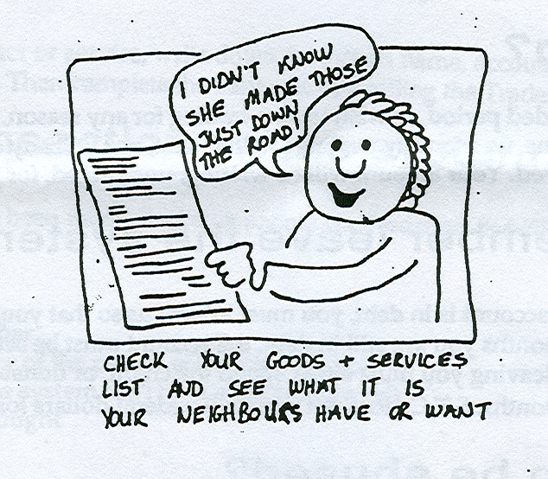
WHAT DO I HAVE TO OFFER?

Members of the trading community offer a myriad of goods and services that don’t necessarily have anything to do with how they earn their livlihood. From baking bread, knitting sweaters, providing childcare, renting a truck, providing foodstuffs, photography services, rides to the city, tutoring, good used clothes, art and much more! Just ask yourself, “What do I enjoy doing? What might others need?”

STC IS A NON-PROFIT GROUP

The Saugeen Trading Community is a non-profit membership organization. Responsibility for administering the system is entrusted with a 6 member Core Group who are accountable to the membership. There is an Annual General Meeting held in January or early February for the membership at large. The Core Group presents a summary of the year’s activities, including financial statements (saubucks and federal dollars). Any policy change being suggested is presented at the AGM and approval granted by consensus. New Core Members as needed are elected for a three year term at the yearly meeting as well. After the business meeting, we break bread with a potluck luncheon.

HOW IS STC FUNDED?

Members pay a one-time joining fee of $20 and a yearly fee as well. This money is deposited into a non-profit trust account at the Northern Credit Union and is used for operating expenses to pay for all our federal dollar costs which include printing, hall rentals, and miscellaneous. We keep a careful eye on our costs to keep member fees as low as possible. In addition, there are saubuck service charges for administration. Each Core Member (6) receives 10 saubucks for attending monthly meetings and in addition, 10 saubucks/hour for book keeping, newsletter and other jobs that make the system run. Again, these saubuck fees are kept as low as possible and much work is done voluntarily. Currently every member pays 8sb per accounting period or 24 sb yearly. Any major changes to these service charges will be agreed upon by the membership at our annual general meeting.

WHAT ABOUT TAXES?

When you join STC, you receive a copy of Revenue Canada’s fact sheet about “bartering.”
IT-490 explains the tax implications for you. In simple terms, if what you are offering is also how you make your living then it is up to you to report any saubuck income as taxable income. If however, what you offer is NOT your main business then you do not need to report it as income. All responsibility for payments of taxes rests with the members themselves. STC is not responsible for collecting taxes or reporting income tax information to the tax authorities. We do not keep statements after one year, although we do keep track of trading balances for accounting purposes. If you do need statements, it is your responsibility to keep the statements which are mailed to you.

HOW DOES A MEMBER LEAVE THE SYSTEM?

A Member’s Agreement is signed by each new member. It is a legally binding document and outlines responsibilities and expectations as a member of the Saugeen Trading Community. If you wish to resign from STC and your account is in debt, you must inform us so that your account can be returned to zero. If after two months you are still in debt, the account must be settled in federal Canadian dollars. If your account is in credit at the time of leaving, you must either spend the credit, or donate the credit to another member or forfeit that amount after two months. STC does not exchange federal dollars for saubuck credits.

WHAT HAPPENS IF YOU’RE GOING TO BE AWAY FOR A FEW MONTHS?

If you are going away for an extended period you can ask for your account to be made dormant temporarily. Once this is done, no monthly mailings will be sent, nor any saubuck charges deducted until you request that your account be revived. Your account will be waiting, unchanged for your return.

YOU ARE NOW READY TO BEGIN TRADING! HERE’S HOW TO DO IT.

To advertise your goods, services and needs:

When you join, as part of the membership form, you will fill out a sheet with the goods & services you wish to offer other members. Think of it like a newspaper advertisement. You want to state the price of your product or rate for your services and the percentage of saubucks you are willing to accept. These ads become the basis of our G&S Listings. Ads can be changed, removed or updated by you at any time. There are several ways to do this. You can let the G&S Core Member know by *email or snail mail and he/she will make sure that any change is made to always keep the G&S Listings up to date. As a member you can also access our website and using your password make changes yourself. Members who do not use email or who for whatever reason would prefer a printed hard copy of the G&S Listings need only ask. goodsandservices@saugeentrading.com

We produce and send out a regular newsletter by email or by snail mail if you choose this option. You can also view the current and past newsletters on the website. We encourage you to advertise for anything you might also need or want. As well, you can ask that we highlight a good or service you are offering, particularly if it is new or timely. An example involving time of year might be that you are offering to prepare income taxes for members or to help them do so.

Also available is “The Express Line” for goods or services that are time sensitive. For example, you are driving to Montreal and are offering to share the ride and the gas. Or, you have a bumper crop of strawberries that need to be picked immediately. You can email the G&S Core Member who will send out an email to all members. goodsandservices@saugeentrading.com

To buy something:

It’s pretty simple really! Using the G&S Listings contact the member and negotiate the trade. In addition, there are three Market Days a year where members sell their wares and advertise their services. They are held on either Saturdays or Sundays at local community venues. We schedule them as soon as we can every year and announce in the newsletter so that you can plan to attend.

To record a transaction:

Once the trade is completed the saubucks need to be recorded. Unless other arrangements have been made, the buyer will ask for the trade to be recorded. You can do this by email and you can always contact us by *snail mail too. trades@saugeentrading.com or *snail mail to: Saugeen Trading Community, c/o 601619 Sideroad 8, RR#4 Chesley, ON N0G 1L0

The information you send us will look like this:

- your name
- your STC account number
- the name and account number of the person you are buying from
- the amount in saubucks
- the item or service involved and the date
You will receive confirmation that your trade has been recorded.

When buying or selling, here are some things to consider: The price of the item or service is up to you. It can be 100% saubucks, 50 % SB or any percentage you decide. Since this is an alternative currency system we encourage members to have a greater proportion of saubucks than federal Canadian dollars. Sometimes federal money is part of the trade if there are fixed cash costs involved. If the transaction involves considerable saubucks there are two things to remember. It might be useful to have a written agreement outlining details for the understanding and protection of both parties. Any trade involving 200 saubucks or more needs to be approved by the bookkeeper to make sure that the member involved currently has enough credit to accommodate the trade. There is a maximum saubuck debt of 250 saubucks for new members for one year or until a trading record has been established. After that, you can have a maximum debt of 1000 saubucks which is monitored by the bookeeper. Members can confirm the credibility of another member by phoning the bookeeper to ask her/his account number and account balance. This is important if a trade involving considerable saubucks is on offer.

Perhaps the most important thing to remember is that we are a community – The Saugeen Trading Community.

Our mission statement pretty well sums it all up! Let the trading begin!
Updated September,2017

MISSION STATEMENT: The Saugeen Trading Community (STC) is a regionally based monetary system which endeavours to meet economic and social needs of the local community by providing a vehicle for the exchange of labour and goods. We promote self-reliance, community responsibility, local autonomy and ecological sustainability. We support the spirit of co-operation and celebrate the diversity and abundance of skills and resources we have to offer each other.

TRADERS, TRADE ON!

